**Performance of Logistic Regression Model**

To evaluate the performance of a logistic regression model, we must consider few metrics. Irrespective of tool (SAS, R, Python) you would work on, always look for:

1. **AIC (Akaike Information Criteria)** – The analogous metric of adjusted R² in logistic regression is AIC. AIC is the measure of fit which penalizes model for the number of model coefficients. Therefore, we always prefer model with minimum AIC value.

2. **Null Deviance and Residual Deviance** – Null Deviance indicates the response predicted by a model with nothing but an intercept. Lower the value, better the model. Residual deviance indicates the response predicted by a model on adding independent variables. Lower the value, better the model.

3. **Confusion Matrix:** It is nothing but a tabular representation of Actual vs Predicted values. This helps us to find the accuracy of the model and avoid overfitting. This is how it looks like:

[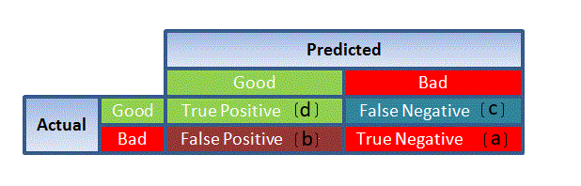](https://www.analyticsvidhya.com/wp-content/uploads/2015/11/1111.png)

You can calculate the **accuracy** of your model with:

[](https://www.analyticsvidhya.com/wp-content/uploads/2015/11/7.png)

From confusion matrix, Specificity and Sensitivity can be derived as illustrated below:

[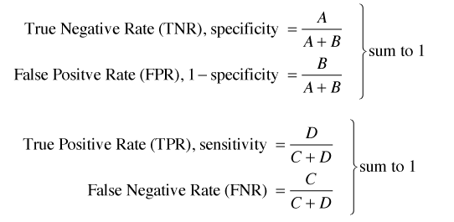](https://www.analyticsvidhya.com/wp-content/uploads/2015/11/9.png)

Let's start with an **example confusion matrix for a binary classifier** (though it can easily be extended to the case of more than two classes):

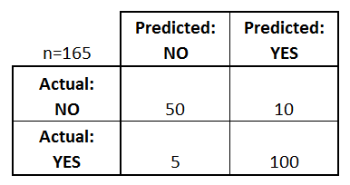

What can we learn from this matrix?

* There are two possible predicted classes: "yes" and "no". If we were predicting the presence of a disease, for example, "yes" would mean they have the disease, and "no" would mean they don't have the disease.
* The classifier made a total of 165 predictions (e.g., 165 patients were being tested for the presence of that disease).
* Out of those 165 cases, the classifier predicted "yes" 110 times, and "no" 55 times.
* In reality, 105 patients in the sample have the disease, and 60 patients do not.

Let's now define the most basic terms, which are whole numbers (not rates):

* **true positives (TP):** These are cases in which we predicted yes (they have the disease), and they do have the disease.
* **true negatives (TN):** We predicted no, and they don't have the disease.
* **false positives (FP):** We predicted yes, but they don't actually have the disease. (Also known as a "Type I error.")
* **false negatives (FN):** We predicted no, but they actually do have the disease. (Also known as a "Type II error.")

I've added these terms to the confusion matrix, and also added the row and column totals:

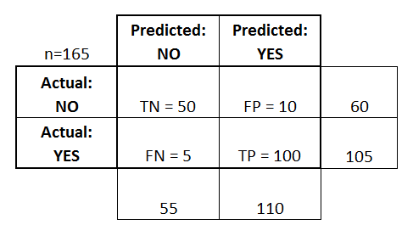

This is a list of rates that are often computed from a confusion matrix for a binary classifier:

* **Accuracy:** Overall, how often is the classifier correct?
  + (TP+TN)/total = (100+50)/165 = 0.91
* **Misclassification Rate:** Overall, how often is it wrong?
  + (FP+FN)/total = (10+5)/165 = 0.09
  + equivalent to 1 minus Accuracy
  + also known as "Error Rate"
* **True Positive Rate:** When it's actually yes, how often does it predict yes?
  + TP/actual yes = 100/105 = 0.95
  + also known as "Sensitivity" or "Recall"
* **False Positive Rate:** When it's actually no, how often does it predict yes?
  + FP/actual no = 10/60 = 0.17
* **Specificity:** When it's actually no, how often does it predict no?
  + TN/actual no = 50/60 = 0.83
  + equivalent to 1 minus False Positive Rate
* **Precision:** When it predicts yes, how often is it correct?
  + TP/predicted yes = 100/110 = 0.91
* **Prevalence:** How often does the yes condition actually occur in our sample?
  + actual yes/total = 105/165 = 0.64

Specificity and Sensitivity plays a crucial role in deriving ROC curve.

4. **ROC Curve:** Receiver Operating Characteristic(ROC) summarizes the model’s performance by evaluating the trade offs between true positive rate (sensitivity) and false positive rate(1- specificity). For plotting ROC, it is advisable to assume p > 0.5 since we are more concerned about success rate. ROC summarizes the predictive power for all possible values of p > 0.5.  The area under curve (AUC), referred to as index of accuracy(A) or concordance index, is a perfect performance metric for ROC curve. Higher the area under curve, better the prediction power of the model. Below is a sample ROC curve. The ROC of a perfect predictive model has TP equals 1 and FP equals 0. This curve will touch the top left corner of the graph.

[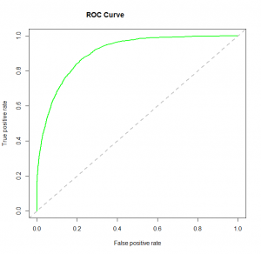](https://www.analyticsvidhya.com/wp-content/uploads/2015/11/logit_roc.png)